EDUCATIONAL LEADERSHIP & POLICY STUDIES
PHD IN EDUCATION
ADULT AND CONTINUING Education CONCENTRATION
HANDBOOK

Updated 09/16/2023
2023 - 2024

Table of Contents

Welcome to the Program! 4
The Adult and Continuing Education Concentration of PhD in Education Major 5
General Goals 5
Key Features 5
Learning Outcomes 6
Program Faculty & Staff 7
Qi Sun, EdD 7
Mitsunori Misawa, PhD 9
Jennifer Kobrin, EdD 10
Jonah Hall 11
Distance Program 12
Graduate School Policy 12
Cohort Model Policy 12
Course Delivery 12
Course Registration 12
Program Curricula 12
Characteristics 12
Requirements 13
Use of Prior Earned Credits 14
Continuous Enrollment of Dissertation hours 14
Exceptions to International students Full-Time Requirement (N/A) 15
Exceptions where a student does not need permission from CIE: 15
Financial Aid 16
Advising and Graduate Committees 17
Semester Group Advisement 17
Establishing Effective Mentor and Mentee Relationships 18
Forming a Program of Study Committee 19
Comprehensive Examination & Admission to Candidacy 20
Timeline 20
Comprehensive Oral Examination 20
Dissertation Proposal 22
Human Subjects Training & ACED 630. ACED 632 22
Institutional Review Board (IRB) 22
Dissertation 24
Retention Policies and Procedures 25
Grounds for Dismissal 25
Remediation Procedures and Steps 25
Student Annual Progress & Evaluation Report 27
Academic Involvement in Professional Organizations 29
Graduation and Beyond 30
Appendices 32
Appendix A – Doctoral Committee Form 33
Appendix B – Admission to Candidacy Form 34
Appendix C – Schedule of Dissertation Defense 37
Appendix D – Leave of Absence Form 38
Appendix E – Time Extension Form 39
Doctoral Student Annual Progress & Evaluation Report 40

Welcome to the Program!

On behalf of the faculty from the Ph.D. in Education Adult and Continuing Education Concentration, I warmly welcome you to our learning family! The Adult and Continuing Education Concentration PhD Online Program in the Department of Educational Leadership and Policy Studies is designed for people interested in working with adult learners in several settings, such as higher education, workplace learning, community-based organizations, government, or any other settings where adults can be found learning. The program has a rich history dating back to five decades. It is distinguished by students who come from varied professional and personal backgrounds, are intellectually curious, and are supportive of the community of students. In interactive online courses, students explore how adults learn and develop through an understanding of research, theory, and reflective practice. With a Ph.D. degree in Education, our graduates use their knowledge of adult and continuing education to advance their careers in such areas as college teaching, university faculty, adult basic education teachers, program developers, leaders in non-profit organizations, training and organizational development consultants, nurse educators, and more.
This handbook will orient you as you begin our distance education program. It provides guidance and references to help you navigate your graduate experience successfully. Please refer to this guide frequently as you progress through your program.
You may also want to visit our program website (to be launched soon) to keep up to date with departmental and program news. Additionally, please also check the graduate website at https://gradschool.utk.edu/. It is to your benefit and in your best interest to become familiar with the rules, regulations, and procedures involved in being a graduate student here at the University of Tennessee, Knoxville.
I am excited to welcome you to our new distance education program! Our faculty members and I eagerly anticipate the opportunity to work and collaborate with you in the future.

Sincerely yours,

Dr. Qi Sun
Associate Professor & Program Coordinator
Ph.D. in Education Adult and Continuing Education Concentration
Department of Educational Leadership and Policy Studies

The Adult and Continuing Education Concentration of PhD in Education Major

The Adult and Continuing Education concentration of the PhD in Education Program at the University of Tennessee, Knoxville, aims to provide a balance between theory and practice. The focus of the program is on helping to develop professionals who can work effectively with adult learners in a wide range of settings and under a host of situations. This internationally recognized graduate program offers learning experiences that prepare individuals to work with a diverse range of adult learners and to live and work in increasingly globalized knowledge societies and more culturally sensitive environments.
The Adult and Continuing Education Concentration of PhD in Education Program prepares students for careers as scholars and practitioners who work with adult learners in a wide variety of settings. The program consists of (1) continuous research or inquiry, (2) courses and professional experiences in adult education and other related fields designed to develop a comprehensive academic basis for future work in research and teaching, and (3) other learning and developmental experiences tailored to individual needs and career goals. Each student works closely with an advisor and a faculty committee who help guide students through the entire process of doctoral study.

General Goals

The PhD in Education Program Adult and Continuing Education Concentration is designed to help students:

- Better understand adult and continuing education in terms of its theoretical and conceptual underpinnings as well as its operation in practical situations;

- Be further prepared for the increasingly changing demands of professional life and personal enrichment;

- Enhance knowledge and skills in assisting adult learners with global visions;

- Broaden ideas and competency to live and work within a knowledge society, and

- Learn skills needed to make contributions to the areas of adult and continuing education through presentations and publication of original research.

Key Features

The PhD in Education Program Adult and Continuing Education Concentration is grounded in several key qualities:

- Inquiry and reflection in the context of a learning community are at the heart of the Adult Learning program. A learning community forms when students engage with each other and with faculty in scholarly activities that contribute to the body of knowledge about adult learning and one’s own professional practice.

- Experience, interests, and abilities of students are valued and considered in the application process and are woven throughout the Adult and Continuing Education program of study. Many students in the program are employed or engaged with adult learners in a wide variety of contexts and/or settings. Their professional experiences contribute to a deeper understanding of the link between theory and practice.

- Cohort Model and Support. Throughout the doctoral program, faculty and fellow students provide guidance and support. Students take two online classes per semester in cohorts, including summer, to build peer networks and engage in academic activities. Faculty and students collaborate on research projects, often leading to presentations at national and international conferences and publications in professional journals.

- Flexibility. Students participate in the newly developed online curriculum with 24/7 access to classes in an asynchronous modality accommodating their full-time or part-time work schedule. This flexibility conveniently serves a wide variety of student needs for learning.

Learning Outcomes

Graduates of the Adult and Continuing Education Concentration in the PhD in Education program possess strong research skills and knowledge of effective adult learning practices.

This program is built around the following learning outcomes:

- Academic Knowledge: Students will demonstrate comprehension of adult and continuing education, along with related fields. They will also demonstrate a comprehensive understanding of diverse approaches to inquiry in educational research and studies. Additionally, they will display proficiency in qualitative, quantitative, and mixed methods, and the ability to steer their own scholarship successfully.

- Practical Competence: Students will demonstrate an ability to work effectively with adult learners in various settings. They will be able to plan, implement, administer, and evaluate programs for adult learners.

- Reflective Inquiry: Students will demonstrate the ability to engage in critical thinking and reflection, both in terms of scholarship and practice.

- Democratic Commitment: Students will demonstrate a dedication to diversity and an understanding of the intricate process of democracy while prioritizing access to quality education for all learners in their professional work.

- Professional Engagement: Students will become deeply engaged with adult and continuing education as a scholarly field, participating in national and international scholarly associations and demonstrating the benefits of membership.

Program Faculty & Staff

Qi Sun, EdD
Associate Professor &
Program Coordinator
519 Bailey Education Complex
1126 Volunteer Blvd.
Knoxville, TN 37996-3452
qsun8@utk.edu

I joined the academic community at the University of Tennessee, Knoxville, in 2016, assuming the role of faculty and the Program Coordinator for the Adult Learning Ph.D. Program within the Department of Educational Psychology and Counseling (EPC). In the context of the college's reimagining initiative, in Fall 2022, our faculty transitioned to the Department of Educational Leadership and Policy Studies (ELPS). Subsequently, in Fall 2023, our newly established online Ph.D. program also relocated to ELPS and was rebranded as the Ph.D. in Education, with a concentration in Adult and Continuing Education.
My scholarly pursuits encompass four primary areas: the Philosophy of Adult Education, International and Comparative Education, Lifelong Learning and Education, and the Asian Diaspora. These interconnected domains underpin my comprehensive research in Adult and Continuing Education. My research methodologies encompass philosophical inquiry, conceptual analysis, qualitative investigation, and quantitative research approaches. These research endeavors have been well-received within the academic community. One of my recent research projects received the 2022 Imogene Okes Award for Outstanding Research in Adult Education, the most prestigious research accolade presented by the American Association of Adult and Continuing Education (AAACE).
I hold a strong commitment to advancing lifelong and life-wide learning on a global scale, extending beyond national boundaries. My unique background in international and comparative education and Asian cultural and educational contexts fuels my dedication to bridging the gap between Eastern and Western research and practice. In this capacity, I leverage my expertise to facilitate academic exchanges among scholars from these diverse regions. Since 2003, I have actively contributed to the leadership and development of the Asian Diaspora Preconference of the Adult Education Research Conference (AERC), evolving it into a prominent global platform for scholars to engage, exchange perspectives, and celebrate diversity within the field of adult education. I have co-edited and published several special issues of academic journals that foster intellectual dialogue between East and West. The most recent special issue published by Emerald in June 2023 explores adult and higher education within evolving global contexts, showcasing innovative theories and practices from Asian countries and beyond. I am a guest editor for several forthcoming issues, including the New Directions for Adult and Continuing Education and Dialogues in Social Justice: An Adult Education Journal.
I have also served in various elected academic and leadership positions at national and international organizations, as Co-Chair of the Executive Committee of the Adult Education Research Conference (AERC), a member-at-large of the Executive Committee of the AAACE Commission for Professor of Adult Education (CPAE), and Chair of the International and Intercultural Special Interest Group (SIG), among other roles. I have served as Co-Editor of Adult Education Quarterly (AEQ) for two terms of five years. I am currently serving on several Review Boards for reputable journals, including AEQ, Adult Learning, Journal of Transformative Education, Higher Education, Skills and Work-Based Learning, New Horizons in Adult Education and Human Resource Development, and Dialogues in Social Justice: An Adult Education Journal. I am honored to have been recognized with the 2023 AAACE Commission of Professor of Adult Education Mid-Career Achievements Award.
In the realm of instruction, I have developed courses that employ comparative lenses to incorporate global perspectives and insights. Additionally, I work to internationalize the field of adult and continuing education by presenting non-Western perspectives in educational theories and practices. My commitment to providing online learning opportunities for adult learners, thereby expanding their access to education, has been a focal point of my recent research. I aspire to further investigate and enhance online learning outcomes for both learners and instructors through continued research endeavors and publications.
My passion for advancing student success motivates me to dedicate significant time and effort to my students. I am deeply honored to have received the 2022 Excellence in Graduate Advising Award from the University of Tennessee, Knoxville, as well as the 2021 Excellence in Graduate Student Mentorship Award from the EPC department. It was equally humbling to be nominated by my students for the 2021 Excellence in Graduate Student Teaching Award within the EPC department and the 2020 UT Chancellor's Honors Excellence in Teaching Award.
I reside in Knoxville, Tennessee, with my husband, Jun, and our two children. Our children are pursuing their education at the University of Tennessee, Knoxville, as undergraduate and graduate students, solidifying our identity as a Vols family.

Research Interests

- Adult learning and development, lifelong learning, and learning societies
- International and comparative education
- Non-Western perspectives on teaching and learning
- Cross-cultural, international learners, and transformative learning
- Online teaching and learning in adult continuing and higher education settings

Mitsunori Misawa, PhD
Associate Professor
521 Bailey Education Complex
1126 Volunteer Blvd.
Knoxville, TN 37996-3452
865-974-5440
mmisawa@utk.edu

Dr. Misawa is an Associate Professor and Associate Department Head in the Department of Educational Leadership and Policy Studies at the University of Tennessee, Knoxville. His major areas of research center on social justice and encompass the intersectionality of race, gender, and sexual orientation, academic and workplace bullying, transformative learning, policy and leadership studies, program evaluation, human resource and organizational development, and social sciences research methodologies (qualitative, quantitative, and mixed methods). His scholarly work examines the positionality of agents (faculty, students, and administrative staff) alongside policies in adult and higher education using learning theories and sociocultural concepts such as Critical Theory, Feminist Theory, Critical Race Theory, and Queer Theory to understand how agents influence each other’s educational experiences and determine the ways in which adult and higher education institutions can more effectively serve diverse populations in contemporary society.
Most recently, Dr. Misawa co-edited a handbook, The Palgrave Handbook on Learning for Transformation (2022), which focused on transformative learning and transformation through education in a global context. One of the sections of the handbook that he oversaw focused specifically on critical and post-structuralist perspectives on transformation and transformative education for social justice. His scholarship has been widely published and is well-recognized by national and international scholarly communities.
Dr. Misawa serves in various leadership roles and participates in multiple national and international services in the field of adult education, including Member-at-Large of the Executive Committee of the American Association for Adult and Continuing Education’s (AAACE) Commission of Professors of Adult Education, Co-Charing the Executive Committee of the Adult Education Research Conference, a Board Member of the International Transformative Learning Association, to name a few. He also serves as an associate editor of the Journal of Workforce Education and Development and as an editorial board member for several journals, including Adult Learning, Journal of Transformative Education, The Qualitative Report, Journal of Psychiatry and Behaviour Therapy, to name a few.
Prior to working at the University of Tennessee, Knoxville, Dr. Misawa was a doctoral faculty member and the Director of the Center for the Study of Higher Education at the University of Memphis, an assistant professor at the University of Georgia, where he taught a doctoral qualitative research methods course, and the Director of Training and Staff Development at Central State Hospital in Milledgeville, GA where he developed and evaluated policy training programs for medical doctors, nurses, and administrators. He was also a policy researcher there and developed and conducted quantitative and mixed methods policy studies.
Research Interests
- Adult bullying, incivility, and violence
- Intersectionality of race, gender, and sexual orientation
- Positionality in social justice research, practice, and evaluation
- Professionalism and ethics in adulthood
- Workforce development and training
- Workplace and professional learning

Jennifer Kobrin, EdD
Assistant Professor
Bailey Education Complex
1126 Volunteer Blvd.
Knoxville, TN 37996-3452
Email: jkobrin@utk.edu

I am excited to join the Adult and Continuing Education Program at UT Knoxville in 2023. My research focuses on adult digital literacy and learning as a social, cultural, and historical process. I am especially interested in the ways adults may navigate and resist structural barriers in their lives related to technology, and how adult education programs may integrate learning with opportunities to critique and challenge power asymmetries. Currently, I am involved with a project exploring how adults navigate and make sense of technology platforms as non-neutral entities in education through critical data literacies.
Prior to joining the learning community at UT Knoxville, I served as Director of Digital Initiatives for the City of Philadelphia’s Office of Adult Education, where I developed hybrid and online learning programs and managed a network of public access computer centers across Philadelphia. I am passionate about adult literacy learning and technology and am an active member of several professional groups, including the Adult Education Research Conference (AERC), the American Educational Research Association (AERA) Adult Literacy and Adult Education SIG, and the Literacy Research Association Adult Literacy Study Group.

Research Interests

- Digital technologies in teaching and learning
- Practitioner inquiry in adult education
- Adult digital literacy practices in social contexts
- The role of community anchors in supporting digital equity

Jonah Hall
Marketing & Communications Coordinator
Program Associate

509 Bailey Education Complex
1126 Volunteer Blvd.
Knoxville, TN 37996-3452
Email: jhall152@utk.edu

I have worked at the University of Tennessee, Knoxville since August 2023, serving as the Marketing & Communications Coordinator for the ELPS Department while also supporting the faculty and students of the ESM and Adult Learning education programs. As I grew up near Knoxville all my life, my love for the area started at a young age. The great people and the beautiful campus, just to name a couple, here at UTK are things that make this position so cherished and valuable to me.
Currently, I live in Knoxville and enjoy spending as much time exploring the area as I can. In my free time, I enjoy talking to my family and friends and being active by hiking, playing sports, attending events, and much more. Go Vols!

Distance Program

Graduate School Policy

UTK graduate school policy, students are expected to complete a full-time residency requirement at some point during the program. For our distance program, this requirement consists of enrollment in 6 credit hours of coursework for three consecutive semesters. Please review the cohort model below for the program policy.

Cohort Model Policy
This PhD in Education Program Adult and Continuing Education Concentration uses a cohort model for course delivery. Students take two courses per semester, including summer, completing coursework in just over three years. They then take comps, prepare a dissertation proposal, and conduct dissertation research to be defended. Students are expected to follow the pace of their cohort to successfully complete their degree program.

Course Delivery
This fully online PhD program offers a distance learning experience designed to cater to the needs of adult learners. The program employs an asynchronous course delivery method, ensuring round-the-clock accessibility to course materials. Although the initial stage of the program involves transitioning courses to an asynchronous format, some courses might temporarily adopt a hybrid approach, incorporating platforms like Zoom. Our commitment lies in optimizing the learning journey by leveraging cutting-edge technology to facilitate a seamless and impactful online learning experience.

Course Registration

The program requires students to enroll before each semester by providing their student ID and number to the program associate in the department for course registration.

Program Curricula

Characteristics

The PhD in Education Adult and Continuing Education Concentration program is built upon three foundations to help students become well-rounded professionals. These include educational foundations, learning and development, research and scholarship.

- Educational foundations are focused on the socio-cultural analyses of educational psychology and sociology as they relate to your area of interest. Foundations also include the philosophical and historical perspectives that shaped our field over time. Further, relevant theories and rationales from international and global perspectives that influence past, present, and even future research and inquiry in the field also form educational foundations of the program study.

- Learning and development includes conceptual analyses of human development, learning theories, principles, practices, and/or models from both Western and non-Western perspectives that apply to knowledge and skills acquisition in the program.

- Research and scholarship involves advanced studies in research necessary for understanding, analyzing, and interpreting data and research design. This area also focuses on skills and expertise in conducting, synthesizing, and disseminating original research.

Requirements
- Basic Core Courses (27 Credit Hours)
  - ACED 519 Writing for Professional Publication (3)
  - ACED 520 Survey of Adult Education (3)
  - ACED 521 Program Planning in Adult Education (3)
  - ACED 527 Ethical Issues in Adult Education (3)
  - ACED 528 Adult Education Movement U.S.A: An Examination of the History & Literature (3)
  - ACED 529 Facilitating Adult Learning (3)
  - ACED 538 Non-Western Perspective on Teaching and Learning (3)
  - ACED 539 International and Comparative Adult Education (3)
  - One course approved by the program coordinator (3)

- Advanced Core Courses (18 credit hours)
  - ACED 615 Advanced Study of Adult Learning and Development (Theory and Research) (3)
  - ACED 622 Advanced Seminar in Adult Education (3)
  - ACED 625 Advanced Seminar in Lifelong Learning (3)
  - ACED 626 Advanced Learning in Social Context (3)
  - ACED 630 Learning to Develop and Emerge as Scholars (3)
  - ACED 632 Dissertation Research Proposal Writing (3)

- Research Methods (15 credit hours)
  - Research courses must include classes in research methods, quantitative methodology, and qualitative research, as well as two additional courses as approved by the student’s advisor or the program coordinator.
  - Required:
    - EDPY 506 (ESM) (3)
    - EDPY 559 (ESM) (3)
    - EDPY 577 (ESM) (3)
  - Select two classes from the following:
    - ACED 530 (ACED) (3)
    - EDPY 533 (ESM) (3)
    - One advanced qualitative methods course approved by the program coordinator (3)

- Dissertation (24 credit hours)
  - ACED 600​​​ Dissertation Research

Total 84 hours

Use of Prior Earned Credits (Master degree and doctoral courses taken elsewhere)

Students who enroll in the PhD in Education Program Adult and Continuing Education Concentration come from a wide variety of undergraduate and master’s degree majors and even other doctoral programs (transfer students). Therefore, some students may have taken courses that may be considered and credited to the Adult and Continuing Education Concentration. Requests to use prior earned credits in your program of study will be reviewed on a case-by-case basis and must meet the following requirements:

- Carry a grade point average of B (3.0) or better.
- Can include up to 12 hours taken from the ACED curriculum as a non-degree-seeking student within the time limit.
- Up to 18 credits hours from a master’s degree in adult education program or closely related programs may be used to partially fulfill requirements for this PhD program. With an earned master's degree, there is no time limit on when these courses were taken.
- Courses taken from other graduate programs that a student may wish to use for this program are subject to time limits by the University policy and approval by faculty/committee.
- The student will submit the request, along with relevant supporting documentation and justification to his/her program coordinator. The ACED Faculty will review the documentation and collectively determine whether to approve the use of these credits.

Continuous Enrollment of Dissertation hours

All degree-seeking graduate students must demonstrate commitment to their graduate and professional study to ensure they can complete all degree requirements without delay. Graduate students are therefore required to maintain an active status through continuous enrollment from the time of first enrollment until graduation.
Continuous enrollment is maintained by registering for a minimum of one graduate credit hour per semester (excluding the summer, unless stipulated otherwise by the program or department) until graduation or they must submit a Leave of Absence Form requesting a pre-approved break in enrollment (a sample is included in Appendix E). Failure to submit the form or to enroll for a semester will necessitate applying for readmission. Students who have started taking dissertation hours (course 600) must maintain a minimum of three credit hours per semester during all semesters, including the summer, as stipulated in the policy under "Registration and Enrollment Requirements" in order to comply with the Continuous Enrollment requirement.
The minimum enrollment for international students may be different, and international students always need to check with the Center for International Education (CIE) in order to determine what minimum enrollment, they need to maintain in order to satisfy all enrollment requirements attached to their specific visa.

Exceptions to International students Full-Time Requirement (N/A)

International students must consult with a Center of International Education (CIE) https://international.utk.edu/ advisor before taking less than a full-time load. In some cases, a student must get permission ahead of time for immigration requirements.
When a graduate student has completed all coursework requirements and is only working on thesis or dissertation hours, registering for 3 credit hours is sufficient (also for immigration purposes). An international student must obtain permission from CIE before being enrolled part-time. (Note: Academic definition may differ).

- In the final term of a degree program, a student can register for only the number of hours required to graduate (zero hours is not acceptable). An international student must obtain permission from CIE before being enrolled part-time. (Note: Academic definitions may differ).

- A student who has a medical condition can be enrolled less than full-time or not at all in some cases. A letter from a licensed medical doctor explaining the reasons must be turned in. An international student must obtain permission from CIE before dropping below full-time. This special permission can only be approved for one semester at a time and is limited to a total of twelve months.

- An international student who has a valid academic reason can be enrolled less than full-time. Reasons can include initial difficulty with English, reading requirements, unfamiliarity with US teaching methods, or improper course-level placement.

  - This situation is limited to one semester only. Each case is unique. An international student must obtain permission from CIE before enrolling below full-time.

Exceptions where a student does not need permission from CIE:

- During summer semester (after completing spring semester), an international student does not have to be enrolled full time. The student must enroll in the following fall semester.

- (Note: Departmental rules may require full-time enrollment for some graduate assistantships during summer).

- A student who is on a period of authorized full-time Curricular Practical Training (CPT) or Optional Practical Training (OPT).

Financial Aid

- There are several sources of financial aid available to graduate students. Check One Stop Student Services on the Financial Aid website: https://onestop.utk.edu/financial-aid/

Advising and Graduate Committees

Upon admission, students will be assigned an academic advisor (see your admission letter) who provides general advice to guide them through their coursework during the initial years of the program. Subsequently, faculty members, selected based on specific program criteria, collaborate with students to establish their doctoral program committee. There are several factors that inform this selection process. First, faculty members may share similar research interests to those identified by the student through their coursework and personal exploration, aligning with their intended dissertation research. Second, students may present ideas and concepts that resonate with faculty members, providing a solid foundation for their support. Third, the faculty member's availability and willingness to mentor the student, taking into account their diverse backgrounds and experiences, also play a role in the decision-making process.
Collectively, the faculty ensures that the chosen committee optimally matches the student's research aspirations and leverages the faculty's expertise in the field of Adult and Continuing Education PhD Concentration.
All graduate students will form a graduate committee, working in conjunction with the agreed-upon Chair. Formation of the Doctoral Committees may occur before students complete their final semester of coursework. In essence, during the third year, faculty members will assess students' progress and the evolution of their research interests. This evaluation will culminate in discussions with students to determine the most suitable committee, fostering an environment that nurtures both student and faculty success.

Semester Group Advisement

When you enter the graduate program, we will begin working closely with you. We carefully observe your course study and try our hardest to match your interests with faculty members and students in our program. In fact, this is in line with our admission decision based on your goal and career development and our faculty members’ expertise and readiness to work with you. Common research interests & academic ideas mutually held help create meaningful work between faculty/students, promote collaboration, joint research, & streamline doctoral research.
To begin this process, we provide new student orientation at the beginning of your first semester, introducing you to the program, faculty, department, and more. Further, each semester we will hold a group advising session via Zoom to meet with you and listen to your learning experiences, concerns, and questions to provide clarification and explain the program process. It is always encouraged for students to take varied opportunities to share and discuss their research ideas, and professional and career goals with their advisor, instructors, and program faculty members, who will learn about and then be able to provide you with his or her professional knowledge, suggestions, and guidance for your further development.
Take the time to share with and learn about the research interests you and program faculty hold. Additionally, you can share your learning goals and research ideas in your annual program performance assessment form with the Program Coordinator during the Spring semester (usually in April) as required by the program. Faculty’s research interests are listed in the handbook and perhaps on the program website. Take the time to read some of these resources and discuss them with faculty. Please note, it is typical that your program faculty may have more recent research projects or interests developed that are not yet listed. So, sharing your interests with them is another way of learning from each other. Keep in mind, that the more you take the time to communicate and interact academically with your instructor and faculty members, the better the faculty will be informed to be able to collectively guide and support your graduate study.

Informal networking Active engagement in informal networking with peers, instructors, and accomplished faculty is vital, particularly while navigating your coursework. This fosters the exchange of insights, experiences, and ideas beyond formal education. Attending professional conferences also offers a way to grasp field advancements and research trends, aiding in refining your research interests and focus. Embracing networking as a core aspect of your academic journey nurtures intellectual growth and empowers the development of a unique research niche.

Establishing Effective Mentor and Mentee Relationships

Like any human relationship, the mentor-mentee and student-faculty dynamic thrives on timely communication and idea exchange. Understanding each other's communication styles takes time and openness, crucial for relationship building. As an adult learner, initiating efforts to foster a productive relationship is advised for swift progress. Remember, effective communication is pivotal. Direct queries to the appropriate source to expedite responses and accuracy.

Below are some recommendations:

- University of Tennessee, Knoxville faculty, like counterparts at other universities, juggle various roles – from research and teaching to national, international, and local engagements. Visit the Program/Department/College /University websites for general inquiries, and for further help, reach out to office associates first.

- If you have any questions related to courses, research ideas, conference proposals, or comprehensive exams, please reach out to your designated advisor or chairperson.

- Be sure to schedule appointments with your advisor/instructor/chair or faculty members in advance to secure a date/time and thank them for their time and guidance provided after the meeting.
- Show commitment to your professional development by consistently achieving your learning goals when provided with clear guidelines.

- Creatively explore potential alignments between your research interests and faculty expertise, even if they appear dissimilar initially - brainstorming can yield valuable insights. Additionally, familiarize yourself with their recent work and projects, sharing your own ideas to identify common ground that bolsters your research pursuits.

- Approach feedback professionally. Advisors/chairs aim to offer constructive input for academic success. Feedback fosters growth in academia, emphasizing open dialogue even during challenging conversations.

- In situations necessitating change, like altering research focus, faculty sabbatical, or unforeseen events, open communication is crucial. Both the student and chair should candidly explain the reason. If initiated by the student, contacting a new chair for program guidance is advised. If by the chair, they may recommend an alternative. This ensures understanding, support, and continued assistance in a revised capacity.

Forming a Program of Study Committee

Forming your doctoral committee involves natural discussions between you and faculty, shaped by their assessment of your coursework, research interests, and shared ideas of your research direction. This determines the most suitable Chair to lead your committee for success. Your advisor or other faculty member may transition into your Graduate Committee Chair, guiding you in forming your committee, refining research direction, and steering your dissertation process, along with other members.
Taking the initiative supported by your Chair, you can invite potential committee members whose expertise aligns with your research. Don't be disheartened by declines, as their availability or fitness might be factors. Upon agreement, members should email your Chair.
Once formed, complete the Graduate School Doctoral Committee Form with the Chair and Committee signature, then the department signature and Graduate School signatures. Arrange your Program of Study meeting with guidance from your Chair. Prepare a brief paper on content and methodology. During the meeting, present your research direction, method plan, and timeline for feedback.
A committee form can be found at https://gradschool.utk.edu/academics/forms-central/phd-committee-form/. Sample forms can be found in the appendices at the end of this handbook. For form-related queries, reach out to the Program associate support at the Department of Educational Leadership and Policy Studies.

Comprehensive Examination & Admission to Candidacy

The comprehensive examination includes written and oral sections, both of which must be passed for admission to candidacy and then the dissertation proposal stages. The comprehensive exam assesses doctoral students' grasp of adult and continuing education, encompassing research and practice, and their readiness for the dissertation phase.
In the Adult and Continuing Education PhD Concentration, the written part comprises two segments with four topic areas. The student's advisor seeks questions from the committee members after the student presents the research content areas and proposed methods at the first committee meeting. These queries align with committee members’ expertise and are developed collaboratively with the student. Responses, resembling substantial scholarly papers, span 20 to 30 pages in APA 7th edition format (excluding citations and references).
The second written part involves crafting a publishable manuscript, demonstrating deep knowledge in a specific field aspect. The student, in consultation with the Chair, selects a peer-reviewed journal, following its guidelines. The manuscript should match the journal's style and content standards. While submission before the exam date is possible, the student must be the sole author for this portion of the exam.

Timeline

Students, in collaboration with their academic advisors and then the Chair, will develop a plan for the comprehensive examination and establish a timeline. This may be done during or after the last semester of coursework. As the program applies the cohort model, students may take the comprehensive exam in a course after the final semester of coursework. Students will have a semester to complete and submit their written comprehensive examinations.
Comprehensive examinations must be taken within five years, and all requirements must be completed within eight years, from the time of a student’s first enrollment to complete the program of study in a doctoral degree program. If there are extenuating circumstances that warrant a time extension, the student must submit a Request for Time Extension Form. A sample is located in Appendix F of this document.

Comprehensive Oral Examination

Upon completing the written examination, students inform their Chair to arrange an oral examination date, which can be set when they begin the exam or after finishing the written part. Oral defenses are scheduled in the following semester in which they took the exam-Spring, Summer, or Fall. Responses to questions and the manuscript (topic area consulted with and agreed upon with the Chair) must be submitted electronically to committee members two weeks before the oral exam; printed versions may be preferred by some.
Oral examinations generally run for about two hours. Committee members inquire about the written work, assessing both scholarly writing and the ability to engage in academic discourse. Students should collaborate with the Chair for preparation, being ready to present their written work and address questions across various areas.
At the exam's conclusion, the committee decides among three options: (1) pass, advancing the student to candidacy for dissertation proposal, (2) conditional pass, requiring specific additional work, or (3) failure, with potential reexamination. Passing the comprehensive exam leads to the admission to candidacy. Failing the comprehensive exam twice results in program termination.

Advising Form
Ph.D. in Adult & Continuing Education
for Students Admitted Before Fall 2022
Department: Educational Leadership & Policy Studies
Student Name: Semester of Admission:
Advisor Signature: Advising Session Date:
Basic Core Courses (27 Credit Hours) | Credit Hours | Semester
ACED 519 Writing for Professional Publication | 3 | Fa Spr Su 20
ACED 520 Survey of Adult Education | 3 | Fa Spr Su 20
ACED 521 Program Planning in Adult Education | 3 | Fa Spr Su 20
ACED 527 Ethical Issues in Adult Education | 3 | Fa Spr Su 20
ACED 528 Adult Education Movement USA | 3 | Fa Spr Su 20
ACED 529 Facilitating Adult Learning | 3 | Fa Spr Su 20
ACED 538 Non-Western Perspective on Teaching & Learning | 3 | Fa Spr Su 20
ACED 539 International and Comparative Adult Education | 3 | Fa Spr Su 20
One Course Approved by the Program Coordinator | 3 | Fa Spr Su 20
Advanced Core Courses (18 Credit Hours) Credit Semester
Hours
ACED 615 Advanced Study of Adult Learning & Development | 3 | Fa Spr Su 20
ACED 622 Advanced Seminar in Adult Education | 3 | Fa Spr Su 20
ACED 625 - Advanced Seminar in Adult Learning | 3 | Fa Spr Su 20
ACED 626 Advanced Learning in Social Context | 3 | Every other Fa Spr Su 20
ACED 630 Learning to Develop and Emerge as Scholars | 3 | Fa Spr Su 20
ACED 632 Dissertation Research Proposal Writing | 3 | Fa Spr Su 20
Research Methods (15 Credit Hours) Credit Semester
Hours
Research courses must include classes in research methods, quantitative methodology, and qualitative research, as well as two additional courses as approved by the student’s advisor ot the program coordinator.
Required: EDPY 506 (ESM) | 3 | Fa Spr Su 20
Required: EDPY 559 (ESM) | 3 | Fa Spr Su 20
Required EDPY 577 (ESM) | 3 | Fa Spr Su 20
curriSelect two classes from the following:

ACED 530 (ACED) | 3 | Fa Spr Su 20
EDPY 533 (ESM) | 3 | Fa Spr Su 20
One advanced qualitative methods course approved by the program coordinator. | 3 | Fa Spr Su 20
Dissertation (24 Credit Hours)
Total Credit Hours – Minimum 84

Dissertation Proposal

Before you can begin your dissertation research, you must present a proposal to your committee and, if you need to collect human subjects' data, obtain approval from the university Institutional Review Board. Generally, a dissertation proposal contains advanced drafts of the first three chapters of your doctoral dissertation. These include an introductory chapter that introduces the topic, research questions, and significance of the study (Chapter 1), a literature review (Chapter 2), and a detailed methods chapter (Chapter 3). In some cases, you may already have some foundational work from your comprehensive exam, and the ACED 632 class you have taken, which is a course on proposal writing.
Once you complete your written dissertation proposal, you will submit it to your chair for review. If your chair approves the written dissertation proposal, it will be sent to your committee for review. Review by committee members will take a minimum of two to three weeks. If your committee determines that your prospectus is of sufficient quality, a dissertation prospectus oral defense will be scheduled in which you will defend your proposal before your committee. They may ask you to clarify or change certain aspects of your research methodology or literature review, and so on. Once your proposal is approved by the committee, you will need to obtain IRB approval (assuming you are working with human subjects) before you can begin dissertation data collection and analysis.

Human Subjects Training & ACED 630. ACED 632

Before you can submit the online IRB application forms for IRB approval, you must complete a series of training modules offered at http://www.citiprogram.org/. On this site, you will create a user account and complete several modules relating to the safe and ethical use of human subjects data. Upon completing these modules, you will be presented with a certificate of completion. Be sure to save an electronic copy (and print a hard copy) of this certificate. Your certificate of completion for this training must accompany your IRB proposal. You should have gained information and practical experience from taking ACED 630 and/or ACED 632 classes for the following IRB process.

Institutional Review Board (IRB)

Before you can conduct research that involves human subjects, you must obtain permission by the Institutional Review Board at the University of Tennessee, Knoxville. The IRB is composed of university faculty as well as individuals not affiliated with the university. The full board meets monthly to review applications for human subjects research and to determine if subjects and researchers will be effectively protected during the process of data collection, examination, and dissemination. A list of IRB members and meeting dates can be found on the Office of Research and Engagement home page (https://research.utk.edu/compliance/) along with guidelines to submit an IRB proposal (https://irb.utk.edu/).
Although IRB proposals are accepted at any time, they are reviewed according to the IRB’s schedule. Therefore, it is important that you plan ahead. No human subjects data can be collected prior to IRB approval. Please note that IRB approval can be time consuming. A general review of materials can take upwards of 4-6 weeks before feedback is provided. Additional time may be needed to make changes to your proposed study to obtain the approval. Proposals must be submitted at least two weeks prior to a full board meeting to be examined that month. Contact or check the research office website for board meeting schedule.
Currently, all IRB applications at UTK must be submitted through iMedRIS. Since the IRB review process is now accomplished online through iMedRIS, it is no longer necessary to print out and fill out the forms. A typical IRB application contains the following sections:

- Name and contact information of the investigators
- Title of the research project
- Anticipated duration of the project
- Purpose of the project
- Description of human subjects participation
- Research procedures
- Extent to which participants will be identified
- Description of participant benefits
- Description of participant risks
- Description of how informed consent will be obtained
- Copies of consent forms, survey instruments, interview protocols, assessments, and other research documents
- A letter from your committee chair indicating review and approval of the research proposal
- Letters of agreement from other parties involved institutions (colleges, hospitals, schools, etc.)

Dissertation

After your research proposal has been approved (and you have obtained IRB approval, if necessary), you may begin data collection and analysis for your doctoral dissertation research. By this time, you are well on your way to becoming an expert in your field and subject matter. Your literature reviews and previous research should have helped establish you as a scholar in your area. Your dissertation committee and others that you work with have often formed a professional network that will help you succeed in your research. Be sure to continue working closely with these individuals.
Previous work with your dissertation committee should guide dissertation research. Be sure to follow the guidelines spelled out in your prospectus and IRB proposal. Always keep your committee chair advised of your progress. If you encounter difficulties, unforeseen phenomena (e.g., participant risks, procedures outside of your control that influence data collection, etc.) be sure to report them to your committee chair and, if requested, to the Institutional Review Board.
Allow for adequate time to complete your dissertation research. Please remember that although your committee chair and your committee members want you to complete your work in an efficient and timely manner, the most important criterion for completion is submission of a high-quality dissertation. Your chair is responsible for ensuring that you complete a high-quality dissertation. Accordingly, there may be occasions where you are asked to make revisions on how you present, analyze, and interpret your data. To help you maintain balance in this portion of your life, set small goals that lead to your final dissertation completion. Support groups may assist you in your data analysis, writing, and completion. The more graduate students can support each other through this process, the more satisfying the overall experience will be. Your colleagues will hold you accountable, and you will thank them for it in the end.
Be sure to format your dissertation and related requirements based on graduate school guidelines (https://gradschool.utk.edu/academics/graduation/theses-and-dissertations/). Dissertation completion is time-sensitive. Be sure to check university deadlines for graduation requirements: (https://gradschool.utk.edu/graduation/graduation-deadlines/).
When you have completed your dissertation to the satisfaction of your chair, it will be sent to the rest of your committee. Again, university policy states that committee members have two weeks minimum to review this document. If they deem it satisfactory, arrangements must be made for your oral defense. You will contact your committee to verify that all are available, to arrange a physical room or virtually for your oral defense. You must then complete the Schedule of Dissertation Defense Form, https://gradschool.utk.edu/forms-central/schedule-of-dissertation-defense/ at least one week prior to your defense.
Once your oral defense is scheduled, you are responsible for making sure that you send the following information to the program associate so that a defense announcement can be made: the names of your committee members, the day, time, and place of your defense, and the title and abstract for your dissertation.
Upon successful completion of your defense, you will be asked to make revisions to your document and submit your dissertation electronically to the graduate school (Trace). Guidelines for electronic submission can be found at https://gradschool.utk.edu/thesesdissertations/submission/.

Retention Policies and Procedures

In agreement with the ethical guidelines of the American Psychological Association, the Adult and Continuing Education faculty has developed the following student evaluation and retention procedures. Respecting these guidelines, the faculty considers not only academic abilities and skill performance when making retention decisions about students, but also such aspects as whether the student has appropriate levels of engagement in the learning community, connecting to people and learning resources, sensitivity in interpersonal communication to others, and self-awareness for meaningful fellowship and active performance that together holistically facilitate your learning goals and success.
In order to be considered in good standing in the Adult and Continuing Education PhD concentration, students need to sustain 3.0 GPA during their doctoral studies. If a student has less than 3.0 GPA, he or she will be under probation. The faculty will undertake continuous review of each course a student takes in order to facilitate the student’s completion of the program of study and professional success. The Adult and Continuing Education PhD concentration expects all students to practice appropriate professional behavior for leaders in the field of adult education, including integrity in action; courtesy to faculty, staff, and fellow students; consistent progress toward the degree; and compliance with program, college, and university rules. If there is a breach of these standards and requirements, the program faculty will review the student’s situation and recommend corrective action. This may involve a range of actions, from recommending the student seek additional assistance to dismissal from the program.

Grounds for Dismissal

Although faculty members desire to help students remediate problematic performance, a student will be immediately dismissed from the program for the following reasons:

- A student fails to meet the program requirements, including meeting the student annual assessment report and submitting the program-needed materials such as an updated CV on time each year (usually spring semester-early April).
- A student fails to meet the minimum Graduate School requirements as identified in the Graduate Catalog.
- A student fails to pass all of the comprehensive examination questions by the second attempt.
- A student’s cumulative grade point average (GPA) falls below 3.0 on all graduate courses taken for a letter grade of A-F for two successive semesters.
- After implementation of the first three steps of the remediation process (listed below), the student does not improve identified academic performance or professional conduct to an identified acceptable level.

Remediation Procedures and Steps

Those students assessed as having difficulty will receive written and oral feedback concerning their progress from their advisor. All written feedback is placed in the student’s program file, including student written responses to feedback received. Students who are identified as having deficiencies in one or more of the five areas evaluated are provided the following assistance in order to improve their performance:
1. Problem Identification Meeting (PIM)
The advisor/chair meets with the student and gives specific examples of the difficulties, shortcomings, or problematic conduct that have been identified by the faculty. The student and the advisor then discuss minimal change expectations and procedures. A decision is made at this time as to the seriousness of the problem, and if it is recurring. Steps for resolution are recommended, and both parties agree upon a time frame for remediation. A contract is written at this time and is signed by the student and the advisor, with the understanding that the faculty will review the student’s progress at the end of the agreed upon time frame for remediation.

- Recurring or Critical Problems
If the situation is a continuing one, or is critical, a team of faculty members may be appointed by the program coordinator to meet with the student. Concerns will be delineated in writing and given to the student prior to this meeting. During this meeting, the student is given specific information about the recurring or critical problem, the steps needed for resolution, and the time frame allowed prior to determining if further action must be considered. A contract clearly stating areas that need to be improved, and the methods and time frame needed for improvement is written and signed by the student and the involved faculty members. A copy of this agreement is given to the student, and the original is placed in the student’s program file.

- Insufficient Progress, Dismissal, Advising
If the student does not make expeditious progress within identified time frames toward resolution of the identified problem(s), and if the faculty agree that the student will not be able to successfully achieve the academic, teaching, and/or intrapersonal/interpersonal effectiveness objectives of the program, then recommendation for dismissal of the student from the program is considered. If this decision is made by vote of the faculty, it is then forwarded to the department head. The student will be notified in writing.

- Due Process Procedures
Unless the problem involves a major disciplinary action, all of the preceding steps are handled by the Adult and Continuing Education PhD Program faculty. The University and the program policies are written to assure students that their rights are respected, and due process is followed. If a student wishes to challenge a program decision regarding retention in the program, the student has the right to an appeal process, as detailed in the Department Handbook. The Adult and Continuing Education program faculty members believe that the stated procedures are in accord with the accepted educational practices and guidelines of the American Psychological Association Ethical Standards. Faculty members, through continual student evaluation and appraisal, must be aware of the personal limitations of the student that might impede future performance. Faculty members must not only assist the student in securing remedial assistance but also screen or remove from the program those individuals who are unable to provide competent services.

Student Annual Progress & Evaluation Report

Student progress is evaluated annually by their advisers/Chairs through the Student Annual Progress and Evaluation Report. Students must prepare and schedule this meeting with advisers/Chairs by first filling out the form for the report and thinking through the conversations they have had during the past year, and also identifying important goals and accomplishments they would like to achieve in the coming year (see appendix in the Handbook and/or obtain from your adviser), then discussing your self-assessment with your academic adviser during the scheduled meeting. Then the Report needs to be signed by you and your adviser.
As a part of the annual evaluation process, students also need to prepare an up-to-date CV and bring it to their advisers/Chairs at the Annual Progress and Evaluation Report meeting in the spring semester. The Student Annual Progress and Evaluation Report, signed by you and your adviser/Chair, together with your up-to-date CV, then need to be submitted to the Program Coordinator by April 1 for your Program Progress Record.

To facilitate this process,

- Schedule a meeting with your adviser and chair to prepare for your annual progress and evaluation report before the Spring break.
- At the meeting, present your completed annual progress and evaluation report to your adviser, discuss your goals, performance/achievement, and future plans with your adviser, and then you and your adviser sign the Report.
- By Monday of the week following Spring Break, students are required to send an electronic version of the signed Student Annual Progress & Evaluation Report and the up-to-date CV via an email attachment to the Program Coordinator, Dr. Qi Sun (qsun8@utk.edu) and also cc the Program Associate (to be announced) on this email for program records and the program annual assessment purposes.
- Keep in mind that your updated CV may also be required by your advisors/Chair, so send them an electronic version.
- Additionally, students may be required to complete an online Program Survey when needed by the program, which will be sent via an email with a link.

Submitting an annual progress evaluation and updated CV offers students substantial benefits. These documents aid the Program Coordinator and advisors in guiding your academic journey and considering potential awards or fellowships. They also contribute to mandatory University program assessments.
Failing to meet the timeline for the Annual Progress and Evaluation Report and CV submission can result in missed support and opportunities. Non-compliance triggers remediation steps according to program policy (refer to Retention Policies and Procedures).
In case of extenuating circumstances causing delays, promptly inform your advisor and chair or program coordinator to prevent procedure breaches.

Academic Involvement in Professional Organizations

As a doctoral student, you are strongly encouraged to be affiliated with professional associations. Here are some examples:

- Adult Education Research Conference (AERC)
- American Association for Adult and Continuing Education (AAACE)
- American Association for Higher Education & Accreditation (AAHE)
- American Association of University Professors (AAUP)
- American Council on Education (ACE)
- American Educational Research Association (AERA)
- Association of American Colleges and Universities (AAC&U)
- Council of Graduate Schools (CGS)
- Institute for Higher Education Policy (IHEP)
- National Center for Public Policy and Higher Education
- International Society for Self-Directed Learning (ISSDL)
- Comparative and International Education Society (CIES)

During your doctoral study in the program, there are numerous opportunities for you to learn from and collaborate with your advisors, chairs, faculty members, and your peers while participating in these professional activities for presentation, networking, and developing various knowledge and skill sets for your professional and career development. Ask your advisors and chairs and fellow students, check emails from the program and faculty for annual conferences and information in our field for more information.

Graduation and Beyond

The conclusion of your career as a graduate student can be a stressful one. Not only are you finishing your dissertation, planning for a defense that may be months away, but you may also be applying for jobs, anticipating future moves, and trying to establish yourself in a professional community that extends beyond the university. Several steps can be taken to create a smoother transition. These include actively participating in professional communities (local, regional, and national/international) prior to graduating, thinking carefully about what job you want, researching requirements, and establishing specific short-term goals to make yourself more competitive.
Often students conduct dissertation research while concurrently applying for positions. Each of these activities can fill a workday. Be sure to schedule sufficient time for both. Learn how and when positions are posted for your field. Spend time during these last months to apply for positions. Yet, remember that most employers intend to hire people who have graduated. Do not neglect your dissertation work while you apply for positions. A truism that has been repeated for decades but still holds today is that the best dissertation is a completed dissertation.
If you are a PhD student interested in a faculty position in academia you should identify what types of jobs you would like during your first years in your program. When time permits, carefully review position postings and become familiar with the required and desired qualifications for appointments in your field. These qualifications will give you a sense of what skills you need to develop during your career as a graduate student. As you enter your last years in your program, consider applying for one or two of these positions to become familiar with the process. How will you organize your curriculum vitae to position yourself for the job? Whom will you ask to write letters of recommendation? What will you write in your cover letter? This experience will give you confidence as you apply for positions. It will also give you an early opportunity for faculty and peer feedback to improve your portfolio and presentations skills.
Above all, do your homework before you apply for positions. Become familiar with institutional and departmental websites. Learn about the faculty, staff, and department leaders in the units that you want to join. Become familiar with the research and scholarship produced by those faculty who would be most likely to become your closest colleagues and perhaps even search committee members. Learn about the department’s undergraduate and graduate curricula. What classes might you be able to teach? Also, consider completing a brief review of one or more recent dissertations produced by graduate students in the department. If you know someone that works at the institution, approach them and inquire about the position and the community. Are you a good fit for the position? Are you a good fit for the working environment? Would you enjoy living in the community? As a general rule, it is best to apply for positions that you would accept.
Doing this research well in advance of an interview will set you apart from other candidates. When you receive telephone and on campus interviews regarding these positions you will have an opportunity to ask informed questions. By all means, have your own questions for the search committee, for the department head, for the dean, and for the students. Additionally, be prepared to discuss your research agenda, your publication and presentation record, and your goals for research and scholarship over the next five years. Even if you are not offered the position, you will be able to expand your professional network regardless of the outcome. Above all, don’t be discouraged if you do not receive an offer. Obtaining a doctoral degree is hard work. Just getting this far is a reason to celebrate. Take the time to enjoy the moment and reflect on your accomplishments.
It's important to stay in touch with the program, faculty, department, and university as the Adult and Continuing Education program at ELPS of UTK will always serve as your academic "home." Please keep us informed of your updated contact information and professional achievements so we can provide further assistance and follow up with you.

Appendices

Note: These forms change from time to time, so students should always check the Graduate School forms webpage at https://gradschool.utk.edu/forms-central/ for the latest version of the form required.

Doctoral Committee Form A
Admission to Candidacy Form B
Schedule of Dissertation Defense…………………………………………………………. C
Leave of Absence Form ...…………………………………………………………………D
Time Extension Form ……………………………………………………………………..E
Annual Progress & Evaluation Report……………………………………………………..F

Appendix A – Doctoral Committee Form
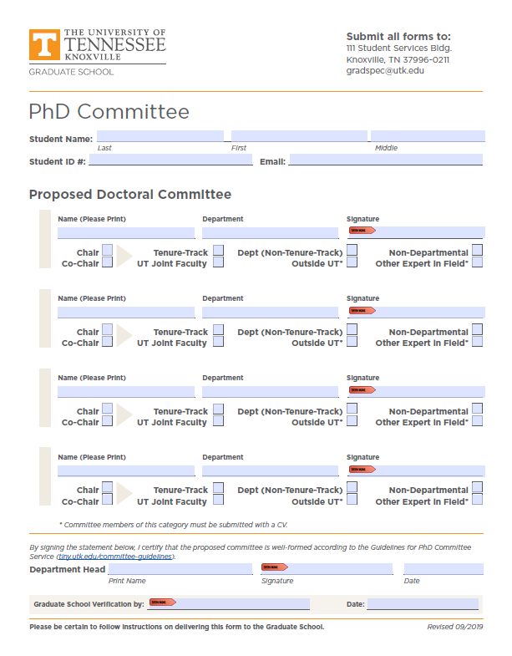

Appendix B – Admission to Candidacy Form
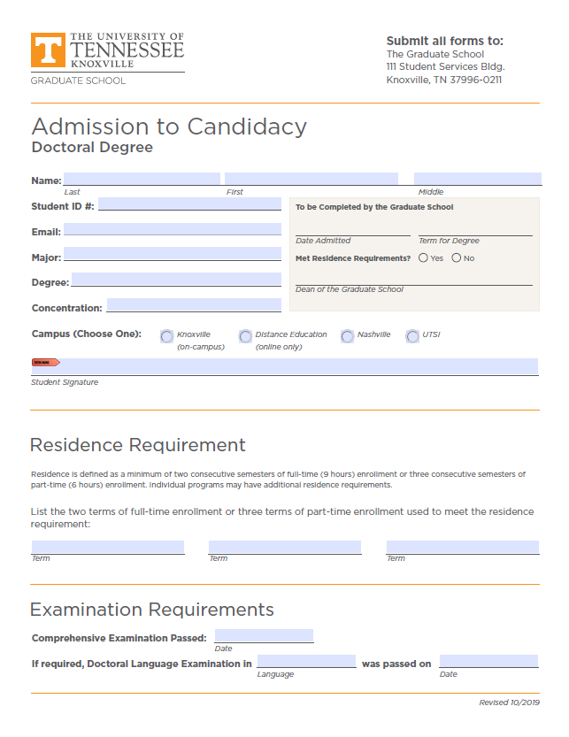

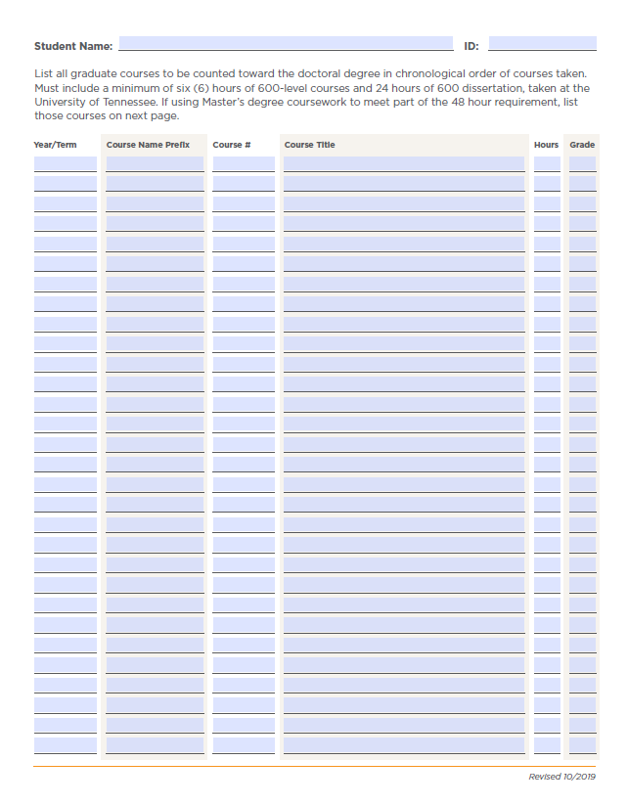
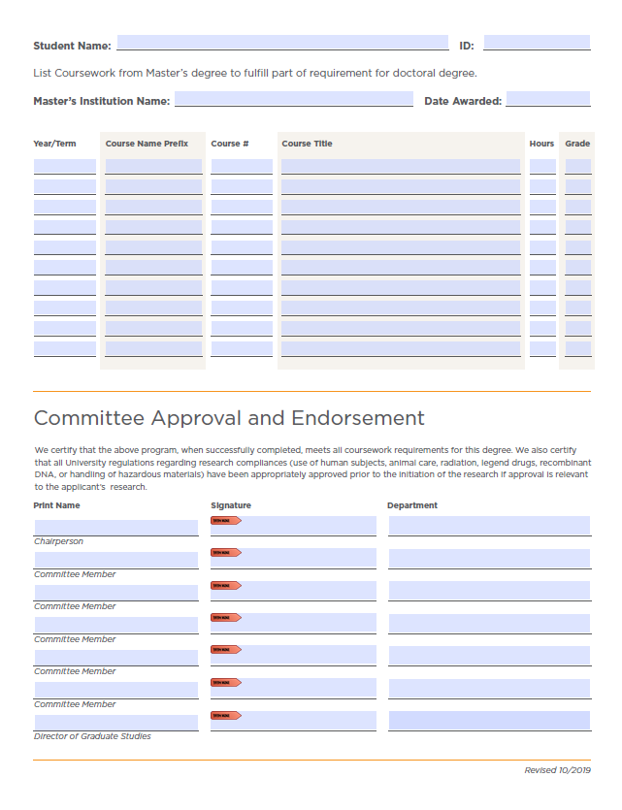

Appendix C – Schedule of Dissertation Defense
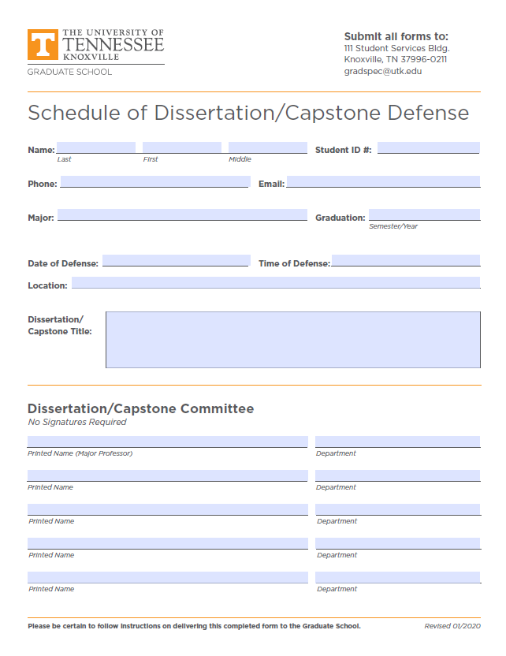

Appendix D – Leave of Absence Form
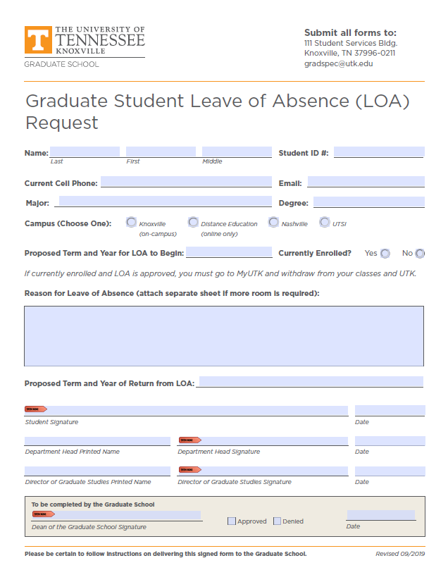

Appendix E – Time Extension Form
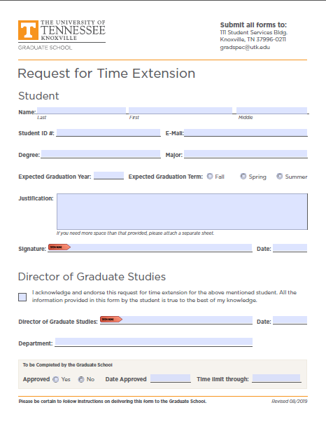

Doctoral Student Annual Progress & Evaluation Report

Ph.D. Educational Psychology and Research
Adult Learning Concentration
Department of Educational Psychology and Counseling
The University of Tennessee, Knoxville

Date
Student Name: Cohort:

Program progress Summary
- Courses completed:

- Comps status:
- Prospectus status
- Dissertation status

Adviser’s Comments and Suggestions for next year/semester

Academic Goals (may include academic conference presentations - sole and/or co-author; journal article writing/publication; participating in/lecturing academic workshop; co-teaching; academic/leadership services)
List Up to FIVE (5) - You may add additional using extra sheets and also to describe and explain each area further if you wish.

1.

2.

3.

4.

5.

Self-Assessment of Achievement – add sheets to describe and explain each area further if you wish.
If this is your first semester in the program, your evaluations will occur next year. However, it's important to discuss them with your adviser.

Not Met Exp. (NME); Met Exp. (ME); Exceed Exp. (EE); In process

Adviser Comments and Suggestions

Future Plans/Goals Identified (List Up to FIVE)

Adviser Comments and Suggestions

Student Signature _________________ Advisor Signature ____________________

Date Date

Program Coordinator Signature _________________________ Date

